USER GUIDE FOR USING THE WEBSITE

1. **Account**
2. ***Register an account***

* Click Register button on Navigation Bar to register as user.

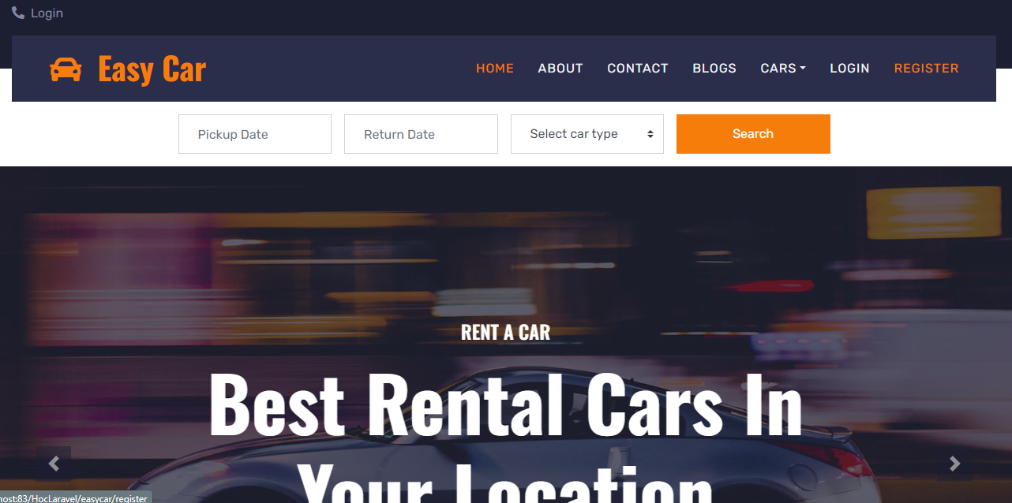

* Enter personal information to register form, then click Submit button

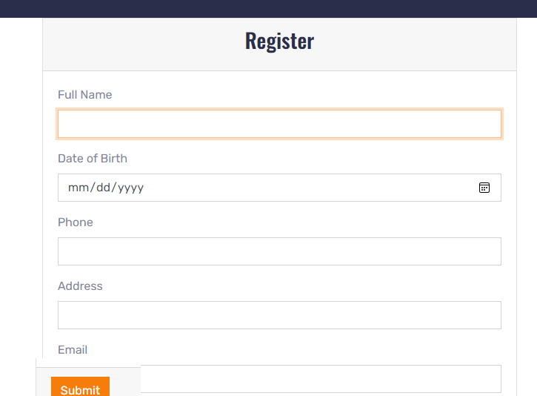

1. ***Login to your account***

* Click Login button on NavBar, then enter email and password match to registered account, then click Login.

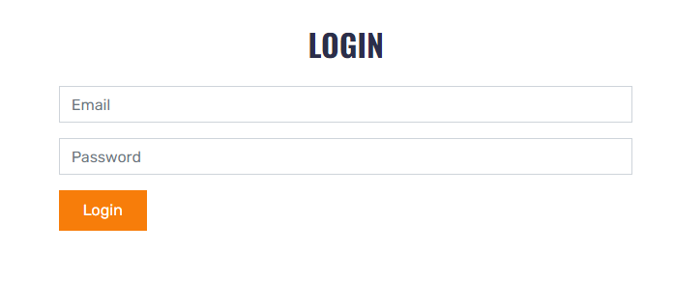

1. ***View profile, booking history, and edit information, password***

* *View profile and edit information:*  Hover on username on NavBar, then click profile button. *You can view or edit your personal info.*

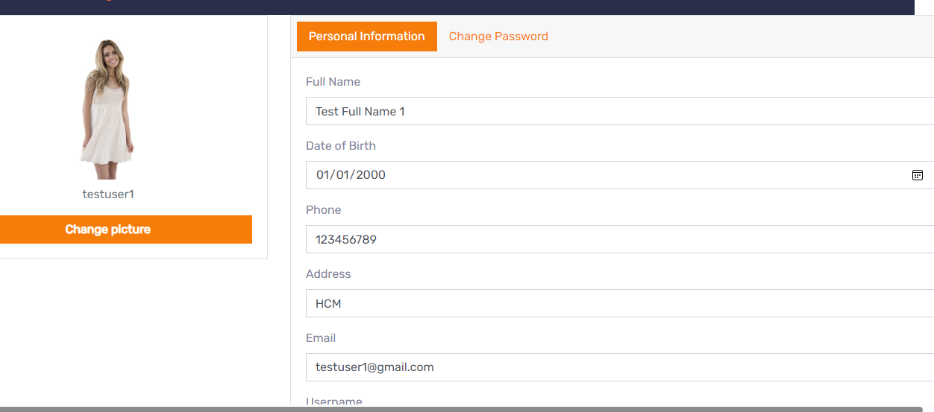

* *View booking history:* Click “Booking History” button to view your booking history

1. **Products**
2. ***Search by schedule or choose by Car***

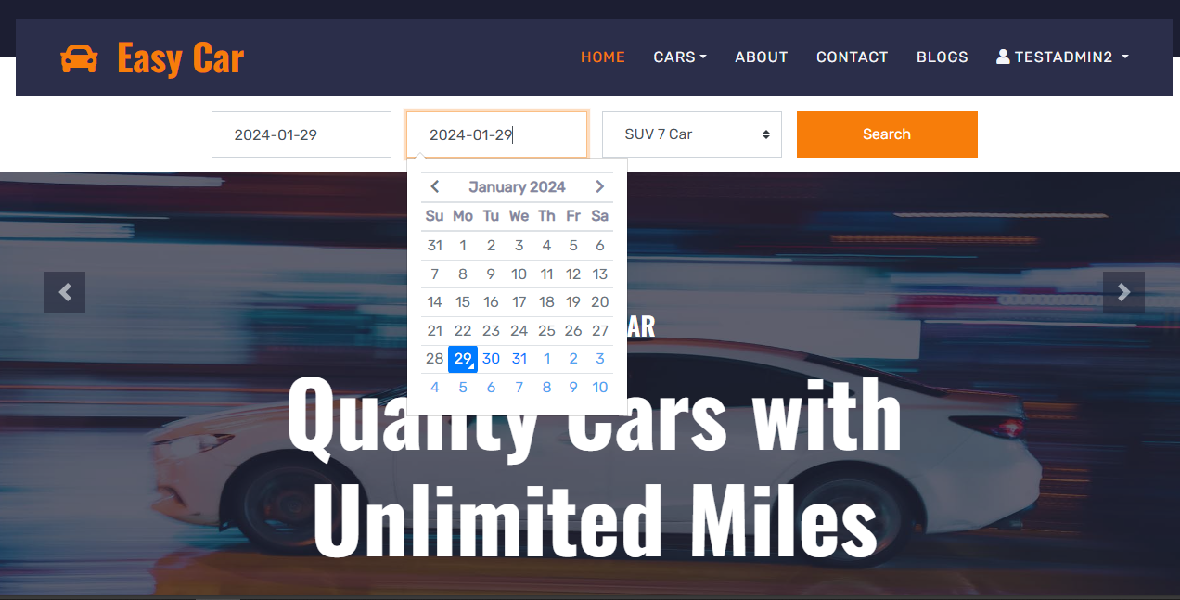

User enter schedule, car type (optional) then click search to search for available car

1. ***View detailed information, leave comment and rate***

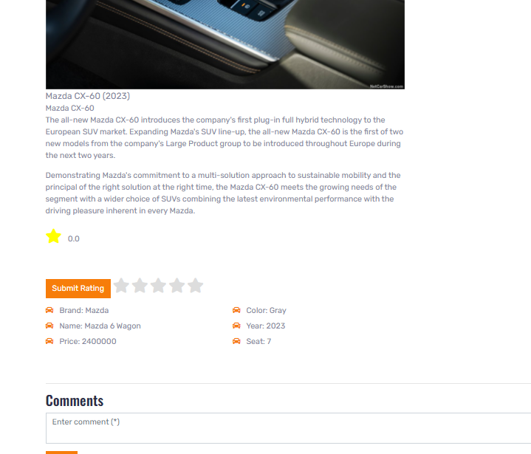

User must login to rate and leave comment.

1. **Booking and Payment**
2. ***Bookbing based on schedule***

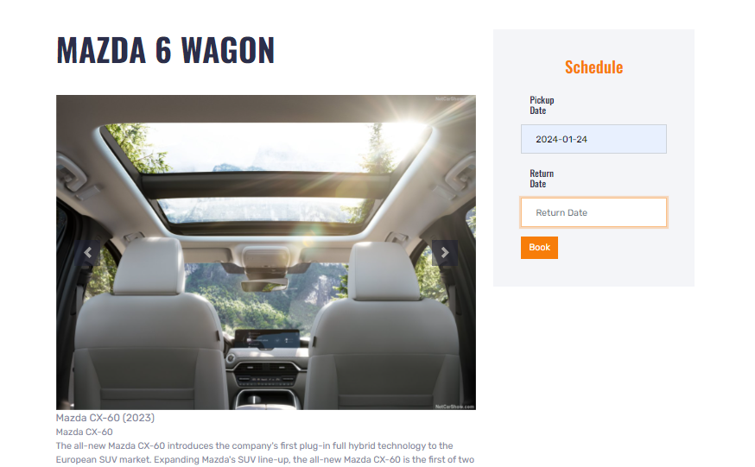

User enter schedule with date format as YYYY-MM-DD to book car. If car not available on user’s schedule, the notice will display

1. ***Payment***

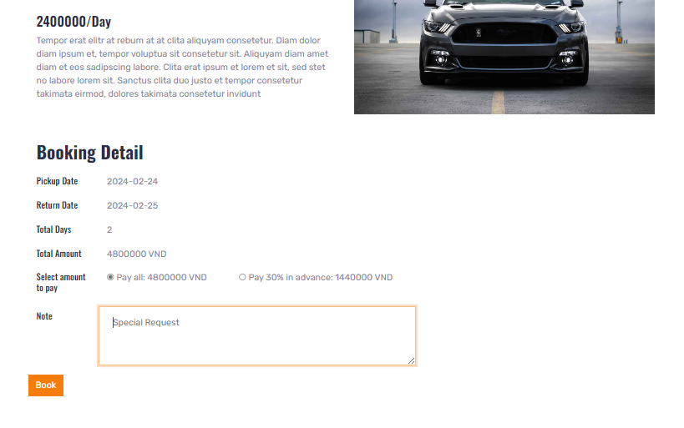

In Booking page, user an choose amount to pay, and leave note. Then click Book button.

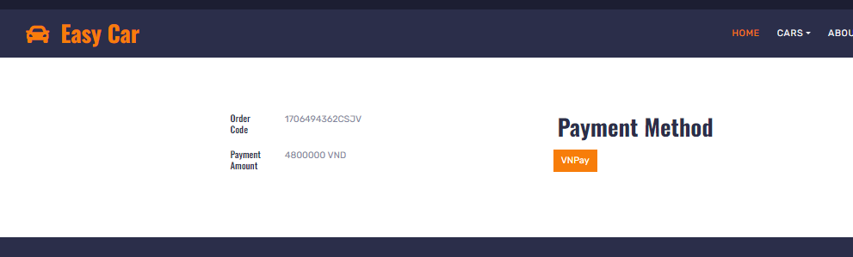

User chooe payment method (VNPay), system will redirect to VNPay payment system. After payment, the website will display success or failed booking.

1. **Blogs and Orther information**
2. ***Read blogs and leave comments***

User click on Blog button on NavBar to read our blogs, and leave comment under the blog content.

**ADMIN DASHBOARD**

**ADMIN DASHBOARD:**

**Main dashboard page**

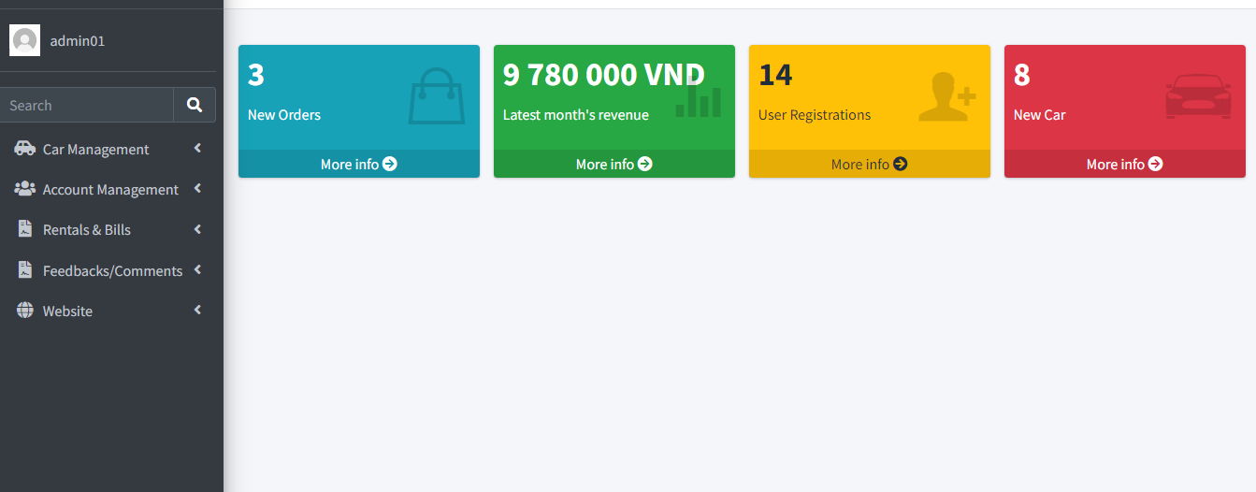

Display overall information of website in nearest 30days, click to More info in each card to view more detail.

The side bar include route to all managegement page of each class.

**Categories**

Click on Categories button on sidebar to redirect categories page:

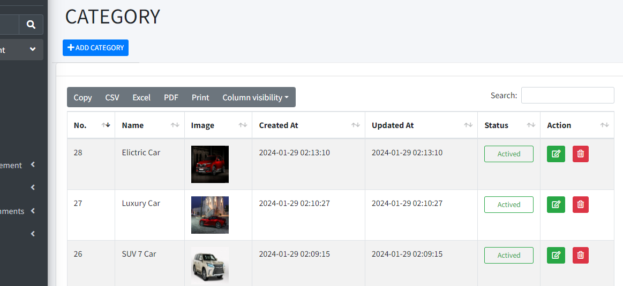

Admin can manage Cartegories (Car types) on this page: add new categories, edit or delete exist categories

**Cars**

Click on Cars button on sidebar to redirect Car management page:

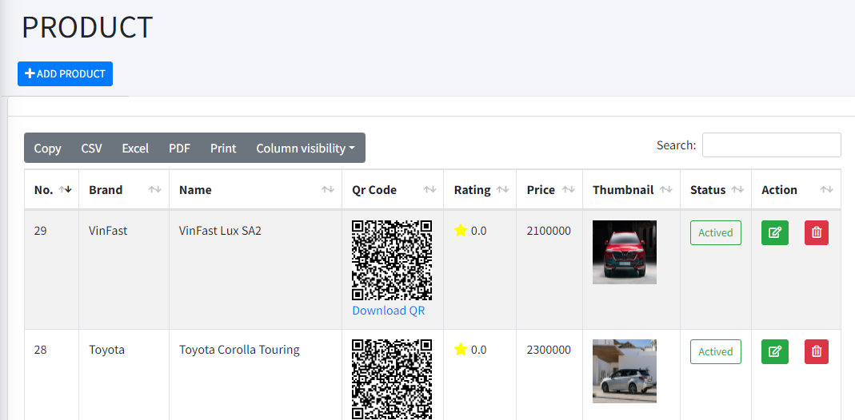

Admin can manage Car infoon this page: add new car, edit or delete existed car by click the button.

**Car ratings**

This page show list of rating that user have rated to the car.

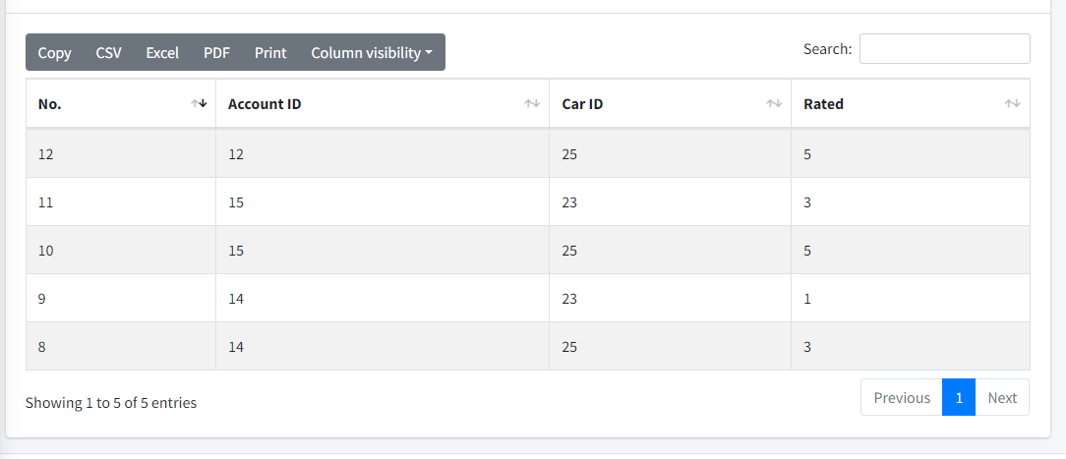

**Comments car**

This page show list of comment that user leave on each car detail page. Admin can reply to the comment here

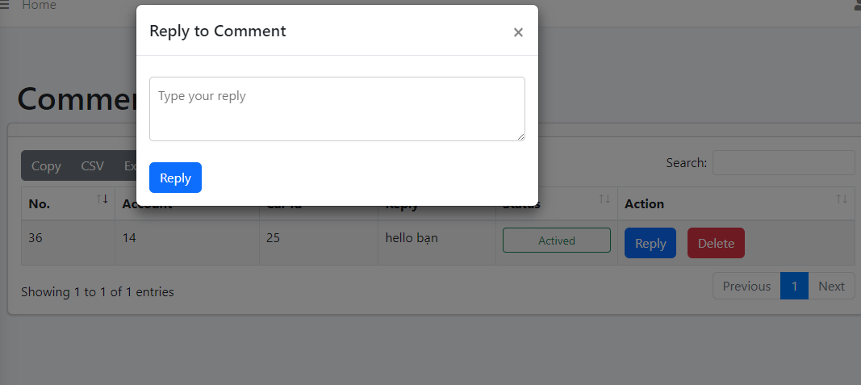

**Account user**

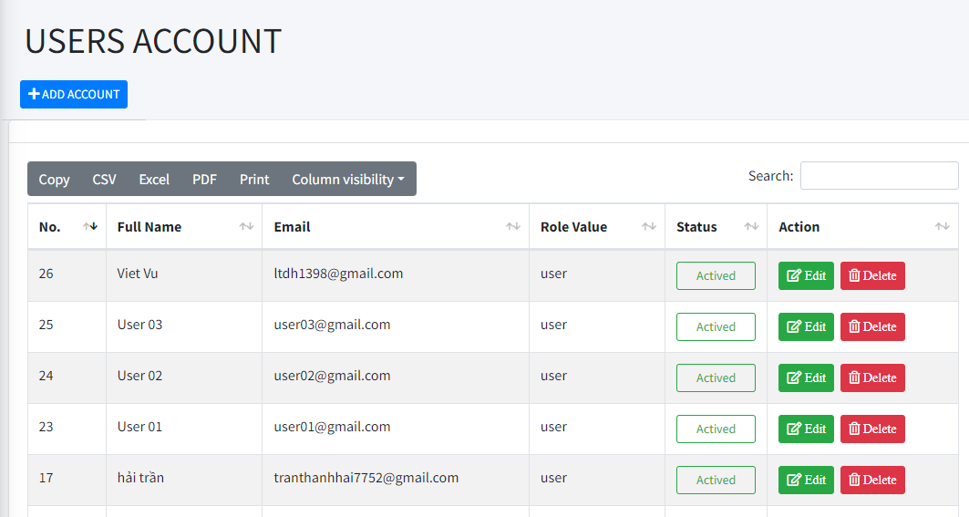

This page show list of all user have registered an account.Admin can edit user profile (if user request), or ban.delete account. Admin also make an user account to moderator of website.

**Account Moderator**

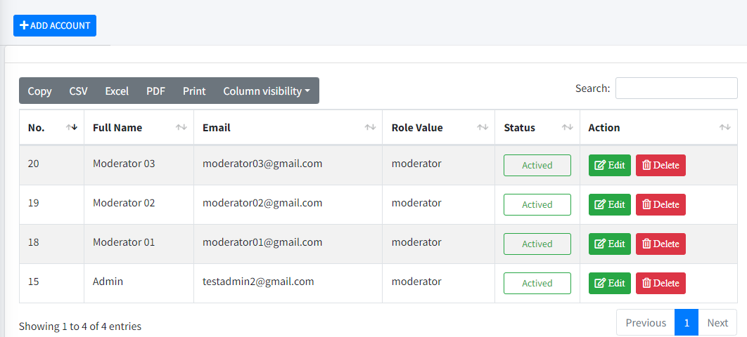

This page show list of all moderator of website.Admin can edit mod profile, or ban.delete account. Admin also can make mod account to user account.

**Rental Order**

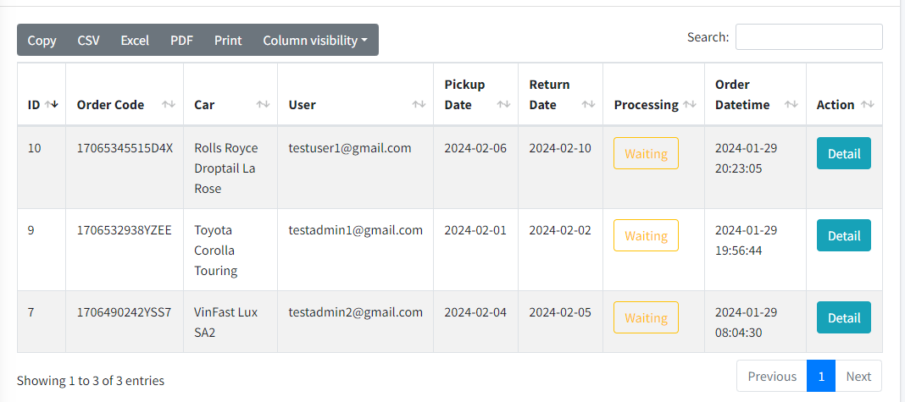

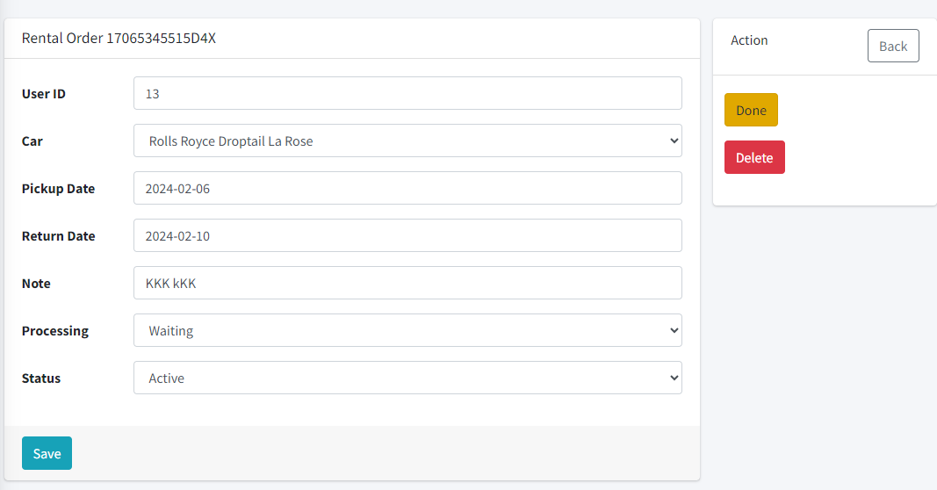

This page show all rental order. Admin can edit each order, delete order and bill of that order. Admin change processing status of each booking after confirm with user, or after user pickup/ return car.

**Bill Detail**

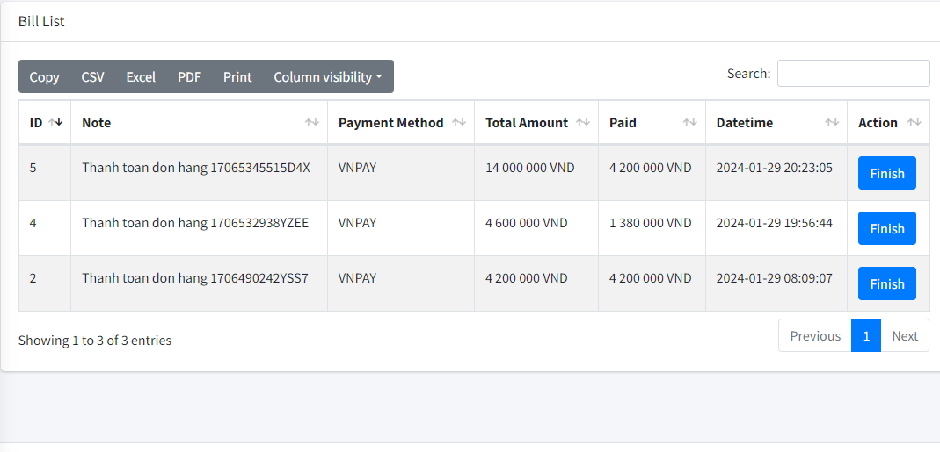

This page show all bill detail. Admin can confirm finish payment of user.

**Feedback**

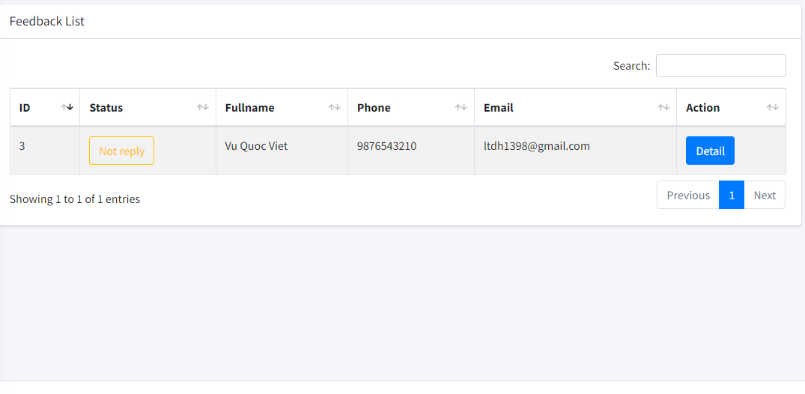

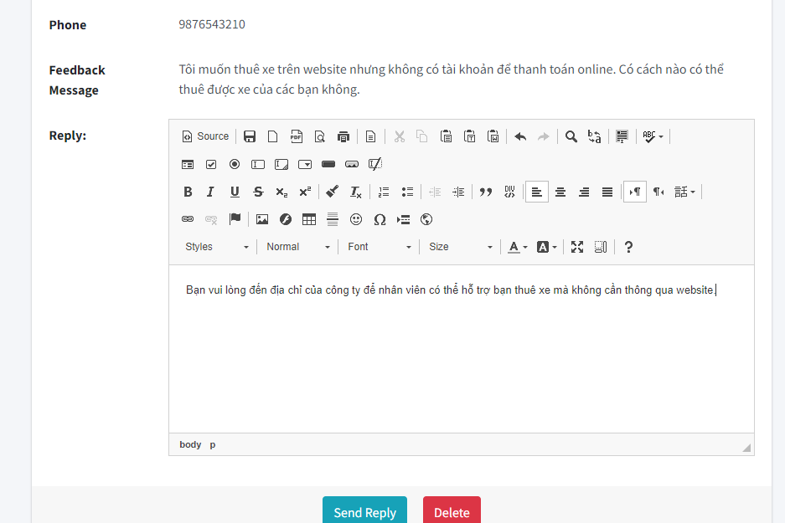

This page show all feedbacks receive from user/visitor. Admin can see all information of visitor, and can reply to them by email, or by phone

**Ads banner/Carousel**

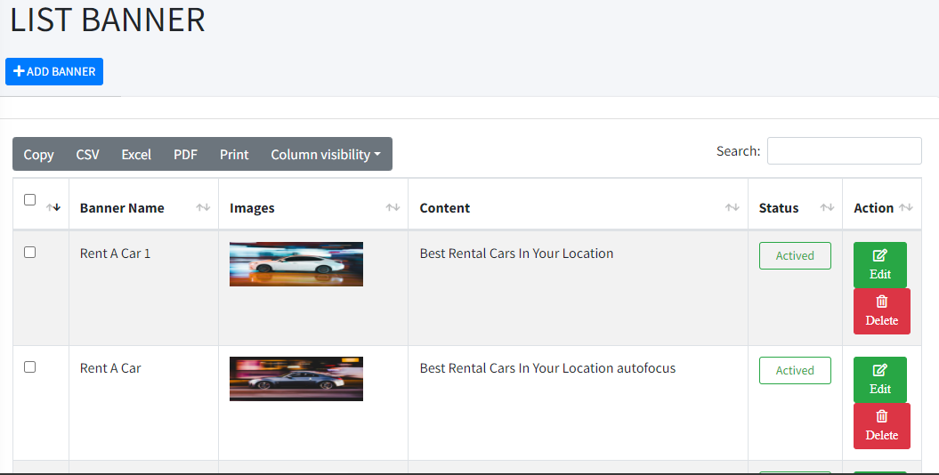

Admin can create, change or edit carousel for ads that display in website.

**Blogs**

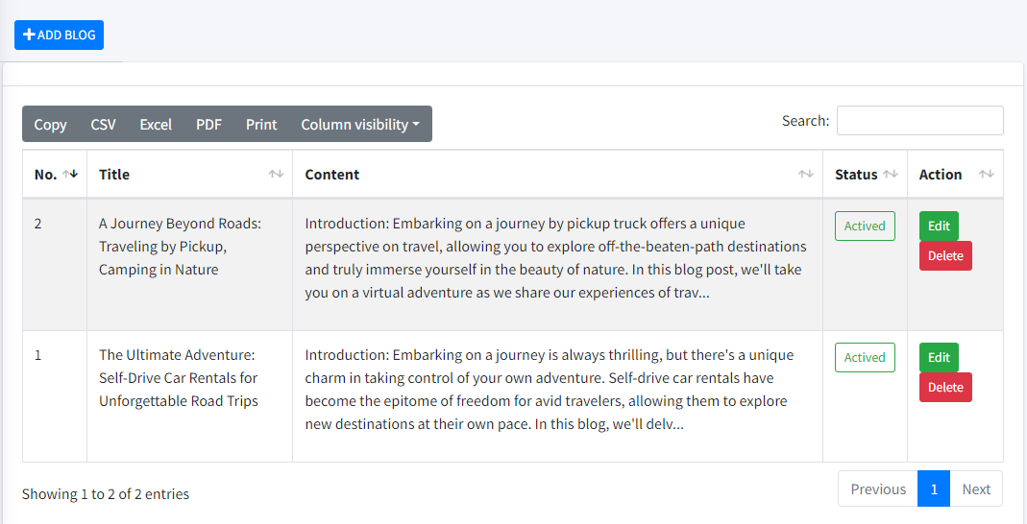

Admin can create a blogs, edit or delete blog in website

**Blogs comment**

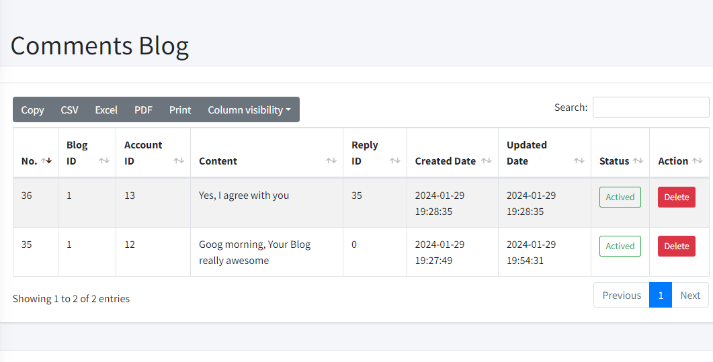

This page show all comment in each blog. Admin can hide or delete violent comment